Stroke Forward: Life Beyond Disability

There are many stories of how the least likely person achieved above all expectations. There is something in all of us that longs to know that achievement is possible. We have read of characters, both real and fictional, who made a glorious comeback, after life has seemingly defeated them. Something happens and their lives are restored to even greater heights than before calamity struck.

The concept of Disability Ministry and Disabilities Awareness is a new area of interest and calling for me. When a disability enters the life of one perso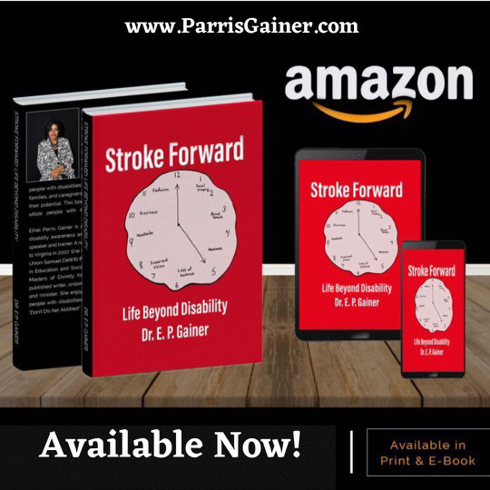n, it enters the life of the family. Disabilities can either create unity, pulling the family together or it can fracture the family, causing division, anger and even isolation. No matter when the word “disability” enters a person’s life, it causes a major life adjustment for the newly disabled person to maintain their identity and be the person they were prior to the disability. This book was written to provide hope and encouragement to people with disabilities and their caregivers to encourage us all to remember the plan that God has for everyone, even people with disabilities.

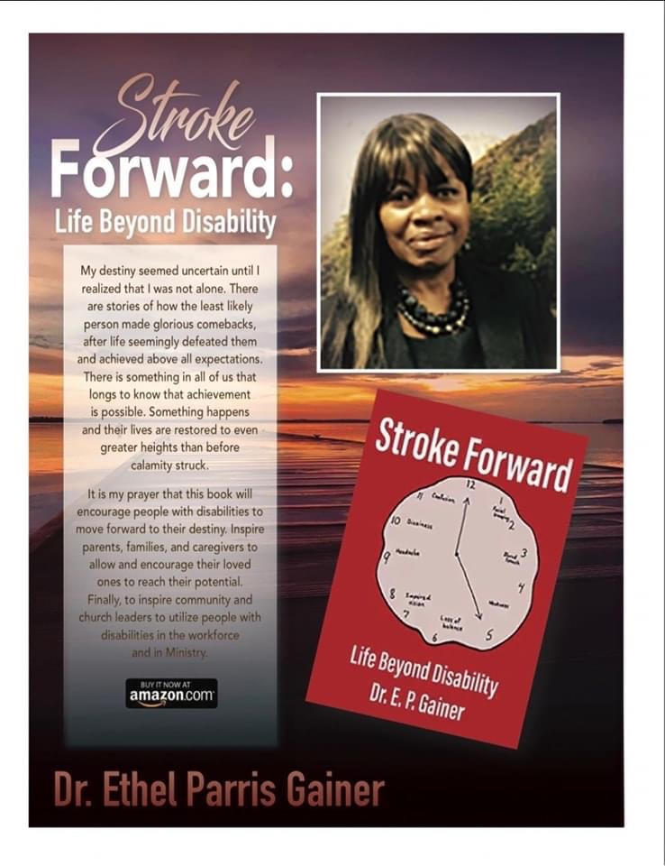

American educator Helen Keller overcame the adversity of being blind and deaf to become one of the 20th century's leading humanitarians, as well as co-founder of the ACLU. Through her many speeches and appearances, s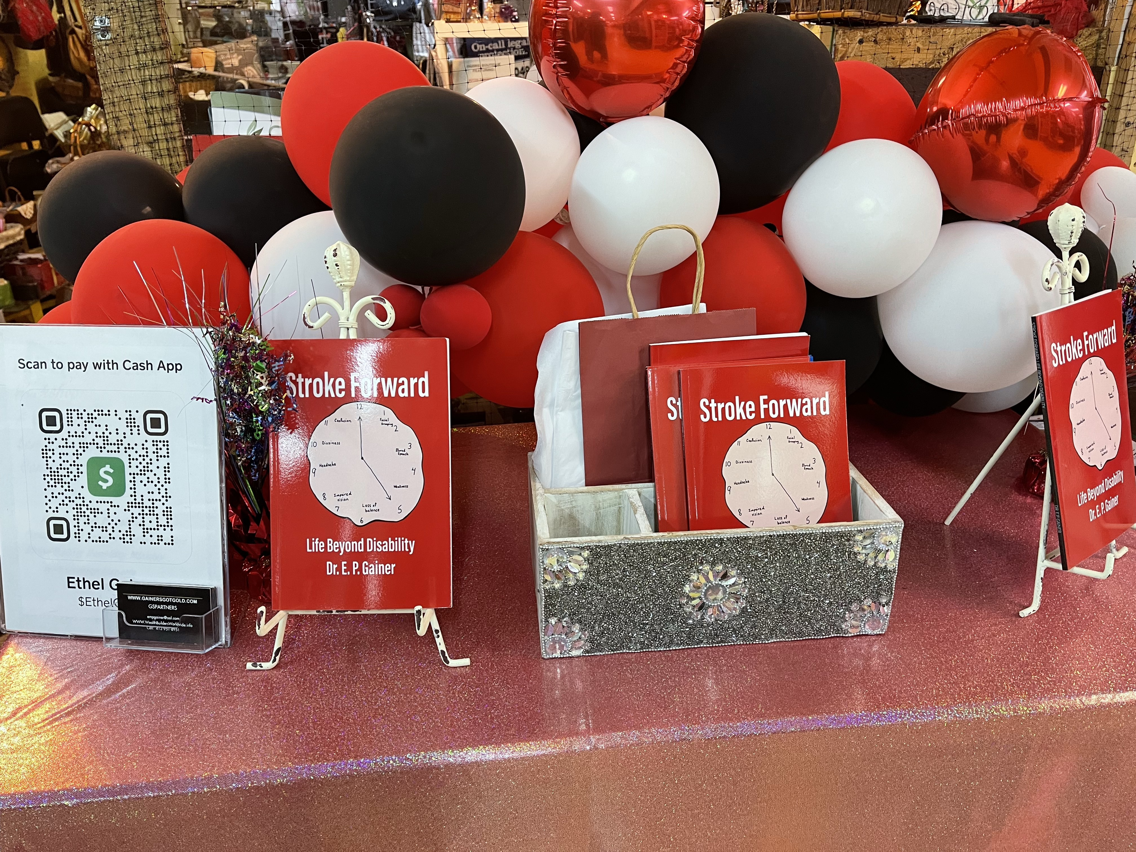he brought inspiration and encouragement to millions of people. By overcoming difficult conditions with a great deal of persistence, she grew into a respected and world-renowned activist who labored for the betterment of others.

ADA- The Americans with Disabilities Act (ADA) was passed July 26, 1990 as Public Law 101-336 (42 U.S.C. Sec. 12101 *et seq* ), and became effective on January 26, 1992. The ADA is **landmark federal legislation that opens up services and employment opportunities to the 54 million Americans with disabilities.** It is not an affirmative action law, but is intended to eliminate illegal discrimination and level the playing field for disabled individuals.